User Manual
  - HUMAN RESOURCE MODULE

  - 

  - All Rights Reserved: Megaplus Technologies
Table of Contents
Starting work on ERP: 4
➢ Login Screen: 4
Login : 4
➢ Employee Entry: 5
➢ Search All Employee: 6
Search Employee: 6
Edit Employee: 7
Employee Card: 9
Employee Confirmation: 10
Employee Resignation/Termination/Retirement/Dismissal: 11
Employee Contract: 12
Employee Academic Improvement: 13
Employee Professional improvement: 14
Employee job History: 15
Employee File Label: 16
Employee Summary Report: 17
Employee Promotion/Demotion: 18
Employee ACR: 19
Employee Status: 20
Employee Contract Detail: 22
Export: 23
➢ Additional information: 24
Edit Employee: 25
Employee Education: 27
Employee Certification: 28
Employee Skills: 29
Employee Additional Info: 30
Employee Relationship: 31
Delete Employee: 32
➢ Active & Deactivate User: 33
Active User: 34
Deactivate User: 34
➢ HR VS Employee / Divide Employee: 35
➢ Staff Information: 36
Search Employee: 36
View Report : 36
Export To Excel: 37
➢ Update Payscale: 38
➢ Status Tracking: 39
➢ Add Department: 39
➢ Add Hospital: 41
➢ Add Sub-Department: 41
➢ Resigned Employee Status: 42
➢ Add Designation: 43
➢ Mark Receptionist: 44
➢ Mark Visiting: 44
➢ Manage User Role: 45
➢ Employee Roles: 46
➢ Employee Roles By Department: 46
➢ Assign Pages To Role: 47
➢ Update Employee Code: 48
Change department: 49

Starting work on ERP:
- Open Chrome, Firefox, Safari or Internet Explorer.
- Enter url in URL Bar:
http://192.168.8.94/demo/login.aspx

Login Screen:

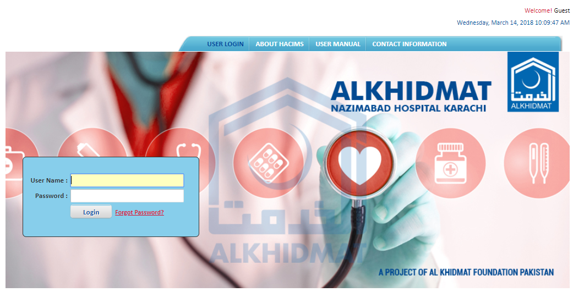

Login :
- Enter login details and click on Login.
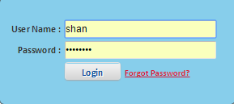

Employee Entry:
- Click on Human Resource Module from menu bar.
- Select Employee Entry for enter new employee.
- Screen will appear as mention below screens:
- Enter the General Information, Basic Information, Address Information, Employment Information.
- Click on save button.
- Employee information will save successfully.
- To reset employee entry click on Reset Button.
(Note: On which text boxes mention the * sign that are compulsory)

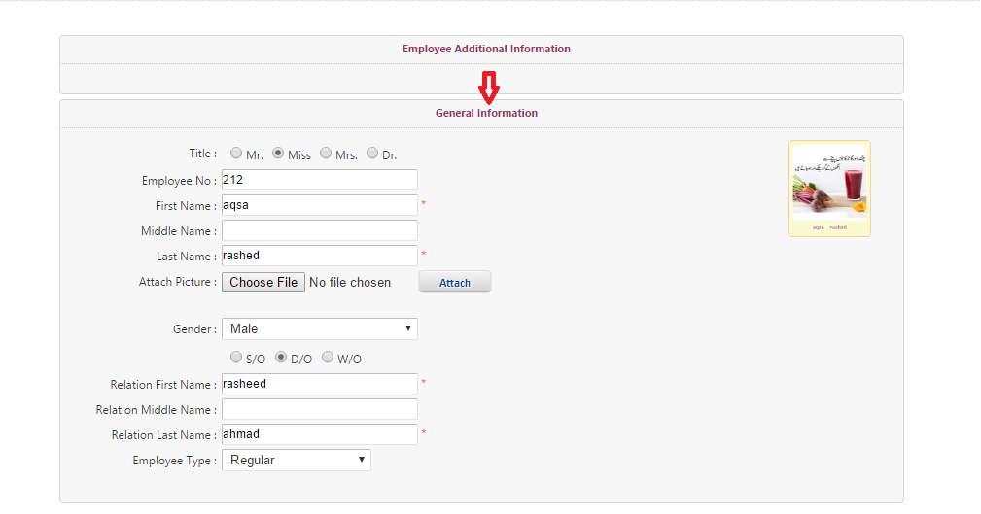
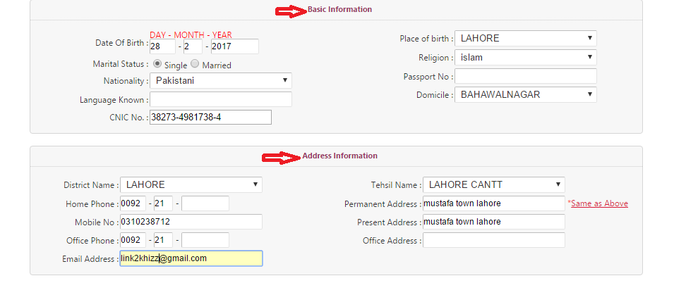

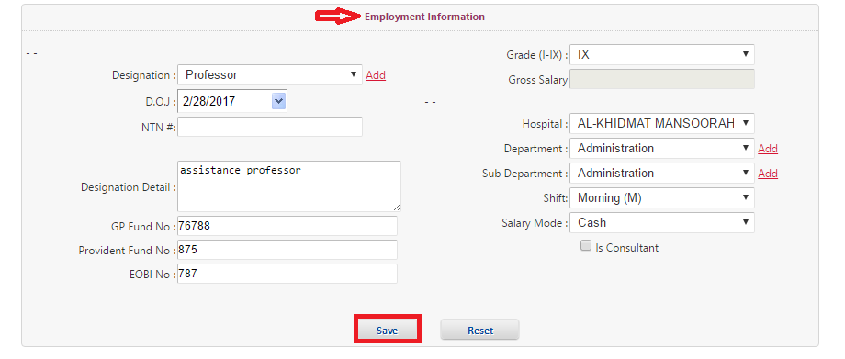

Search All Employee:

Search Employee:
- Click on HR module and select Search Employee from HR module list.
- Screen will appear as mention below:

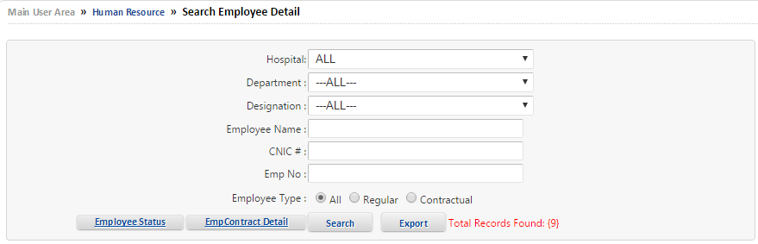

- Click on Search which show on the center of screen. OR
- Search Employee by different parameters by (Hospital, Department, Designation, Employee Name, CNIC #, Employee No),
- When information is entered in the text boxes then select Employee Type by clicking on radio button.
- After selection of Employee Type click on Search.
- Required Employee Information will be filter on screen.

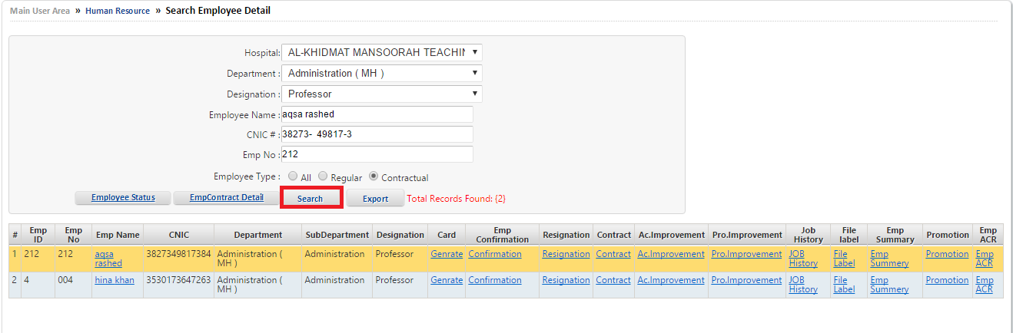

Edit Employee:
- Search Employee by different parameters by (Hospital, Department, Designation, Employee Name, CNIC #, Employee No).
- When Required Employee Information will be searched.
- Click on Emp Name to Edit and Update further information of employee.

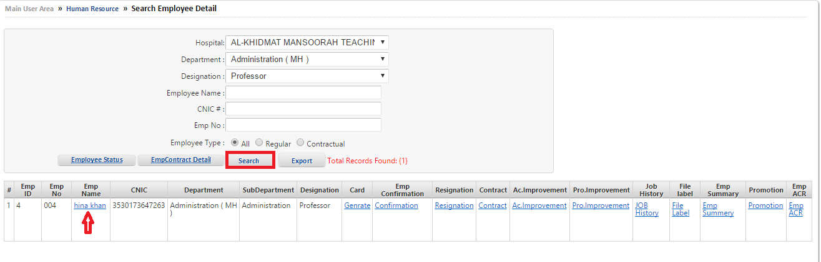
- After selecting Emp Name.
- Edit and Update General Information, Basic Information, Address Information, Employment Information
- Then Click on update.
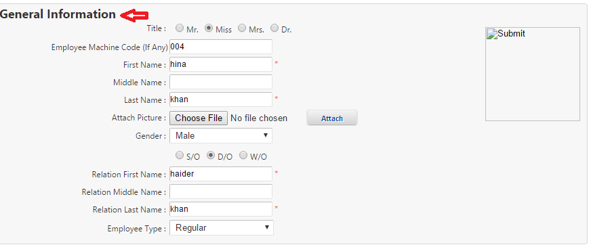
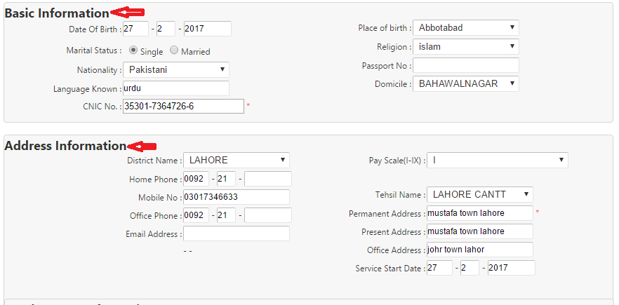
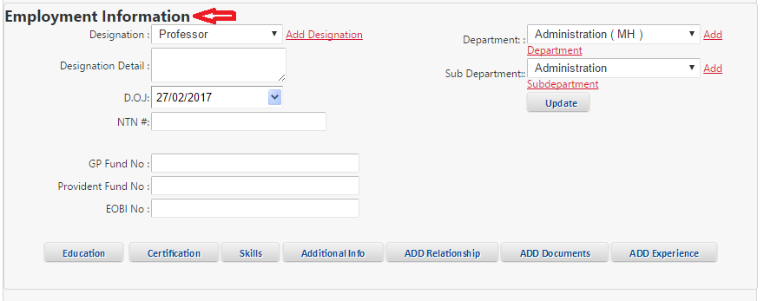

Employee Card:
- Search Employee by different parameters by (Hospital, Department, Designation, Employee Name, CNIC #, Employee No).
- When Required Employee Information will be searched.
- Click on Generate to generate card of employee.
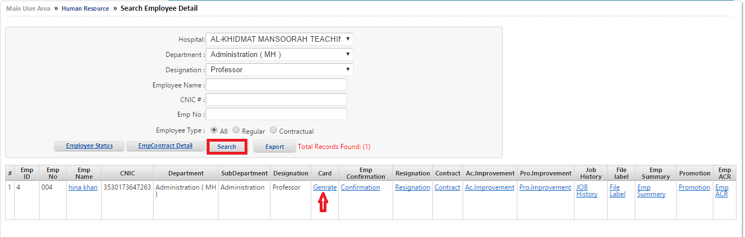

- After selecting Employee Card.
- Screen will appear in which employee Information Card will be generated.

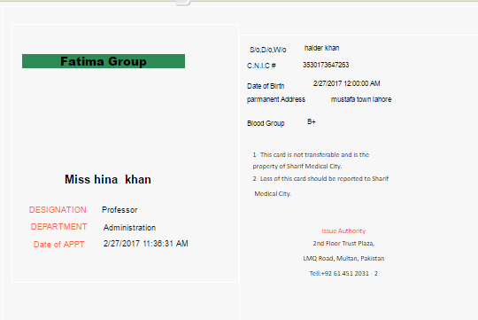

Employee Confirmation:
- Search Employee by different parameters by (Hospital, Department, Designation, Employee Name, CNIC #, Employee No).
- When Required Employee Information will be searched.
- Click on Confirmation to confirm the employee information.

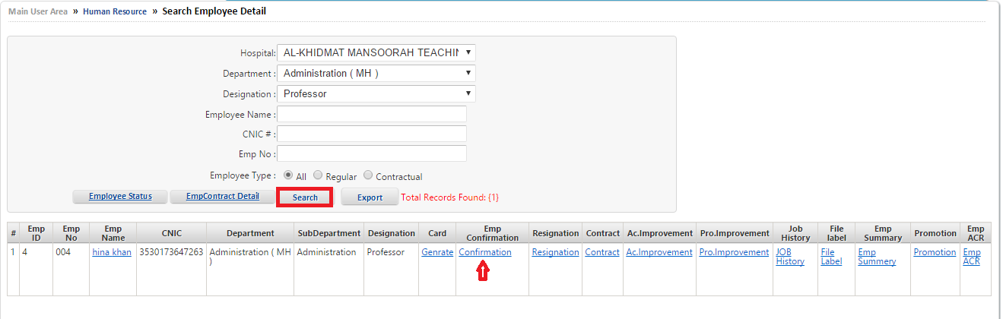
- After selecting Employee Card.
- Employee Confirmation screen will appear as mention below
- Select the name Confirmation Recommended By whom from drop down list.
- Enter Approved Date.
- Enter some Remarks.
- Then Click on save.
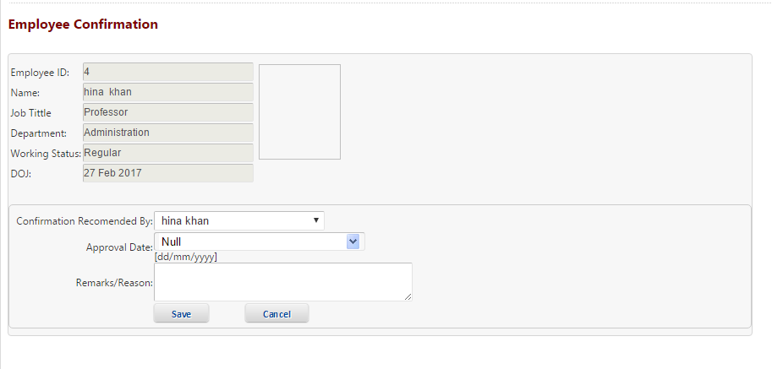

Employee Resignation/Termination/Retirement/Dismissal:
- Search Employee by different parameters by (Hospital, Department, Designation, Employee Name, CNIC #, Employee No).
- When Required Employee Information will be searched.
- Click on Resignation to confirm the employee resignation detail.

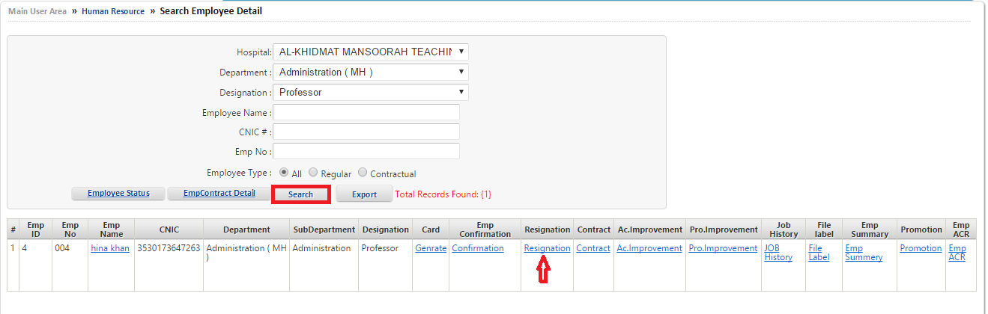
- Select Resignation Type By clicking on Resignation Type radio button.
- Select Resign Date from drop down popup box.
- Select Last Work Day from drop down popup box.
- Enter Notice Period in Notice Period text box.
- Click on Is Approved check box.
- Select Approved Date from drop down popup box.
- Select Approved By from drop down list.
- Enter Resign Reason.
- Enter some Remarks.
- Click on Save button.
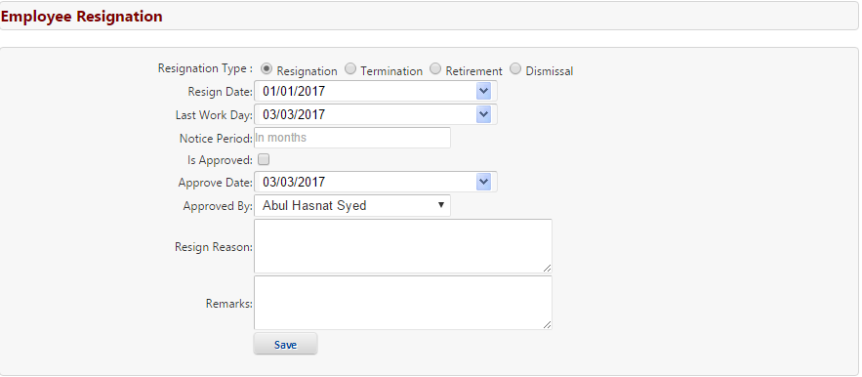

Employee Contract:
- Search Employee by different parameters by (Hospital, Department, Designation, Employee Name, CNIC #, Employee No).
- When Required Employee Information will be searched.
- Click on Contract to finalize the Employee Contract.

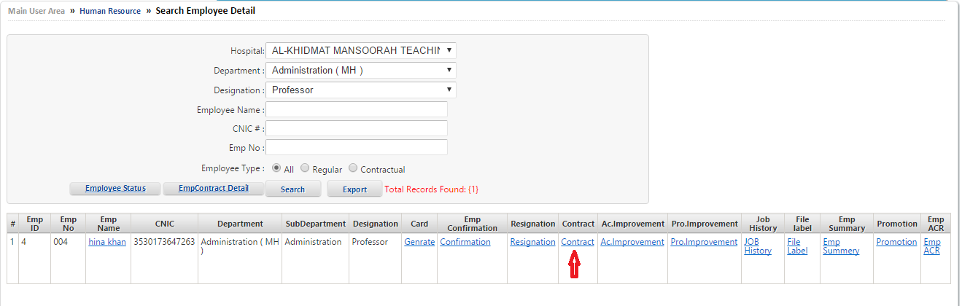
- Select Contract Date from search text box.
- Select Expiry Date from search text box.
- Add Contract Document.
- Select Signing Authority name from drop down list.
- Write some notes.
- Click on Save button.
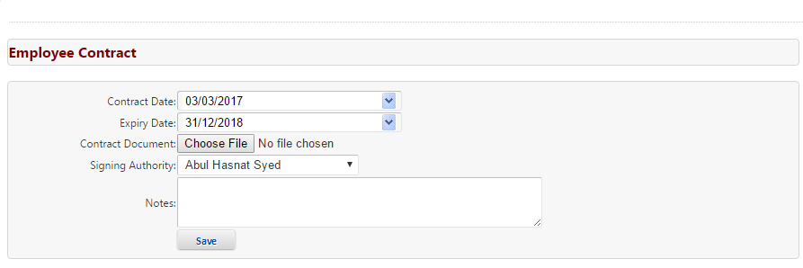

Employee Academic Improvement:
- Search Employee by different parameters by (Hospital, Department, Designation, Employee Name, CNIC #, Employee No).
- When Required Employee Information will be searched.
- Click on Ac.Improvement to see the Academic Improvement of employee.

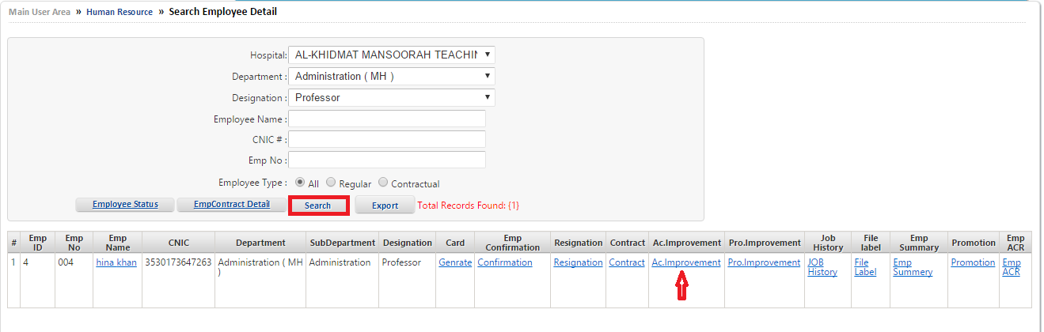

- Enter Certificate Name in Certificate text box.
- Enter Recommended Institute in Recommended Institute text box.
- Select Name from drop down list of Recommended By search box.
- Select Recommended Date from drop down list.
- Select Recommended Till from drop down list.
- Write some Remarks.
- Click on Save button.

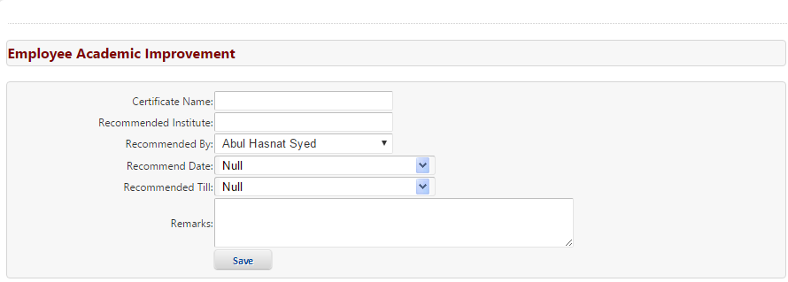

Employee Professional improvement:
- Search Employee by different parameters by (Hospital, Department, Designation, Employee Name, CNIC #, Employee No).
- When Required Employee Information will be searched.
- Click on Pro.Improvement to see the Professional Improvement of employee.

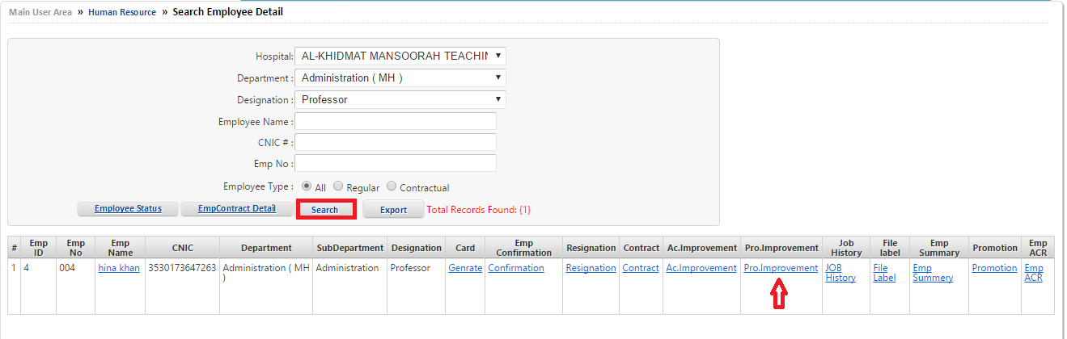
- Enter Certificate Name in Certificate text box.
- Enter Recommended Institute in Recommended Institute text box.
- Select Name from drop down list of Recommended By search box.
- Select Recommended Date from drop down list.
- Select Recommended Till from drop down list.
- Enter some Remarks.
- Click on Save Button.

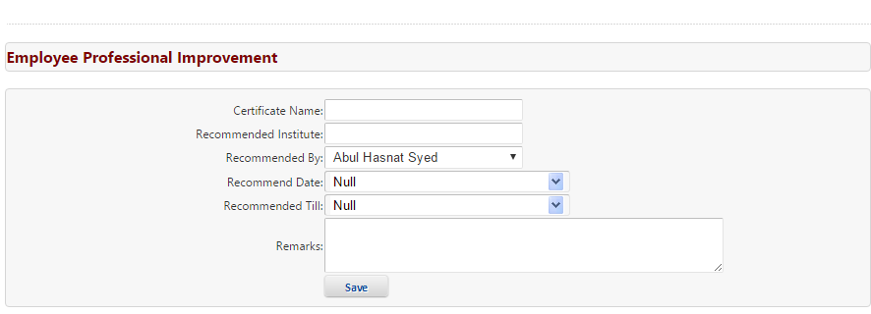

Employee job History:
- Search Employee by different parameters by (Hospital, Department, Designation, Employee Name, CNIC #, Employee No).
- When Required Employee Information will be searched.
- Click on JOB History to see the job history of employee.

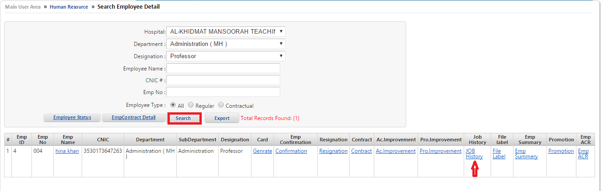
- Employee Job History will appear on the screen.
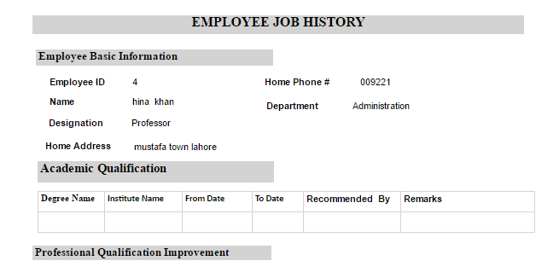

Employee File Label:
- Search Employee by different parameters by (Hospital, Department, Designation, Employee Name, CNIC #, Employee No).
- When Required Employee Information will be searched.
- Click on File Label to see the Detail of employee File Label detail.

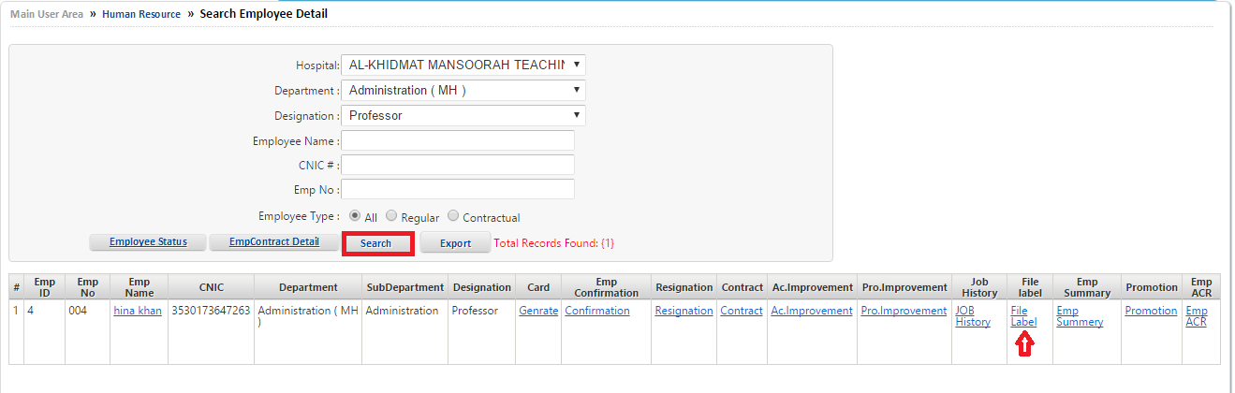
- After selecting employee File Label.
- Employee file label detail will appear on the screen.
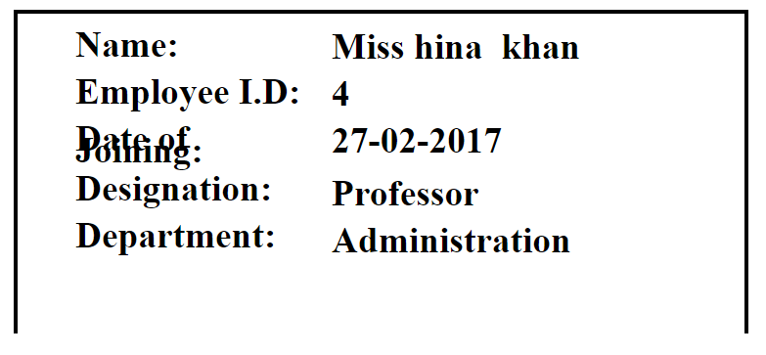

Employee Summary Report:
- Search Employee by different parameters by (Hospital, Department, Designation, Employee Name, CNIC #, Employee No).
- When Required Employee Information will be searched.
- Click on Emp Summary to see the Detail of employee summary report.

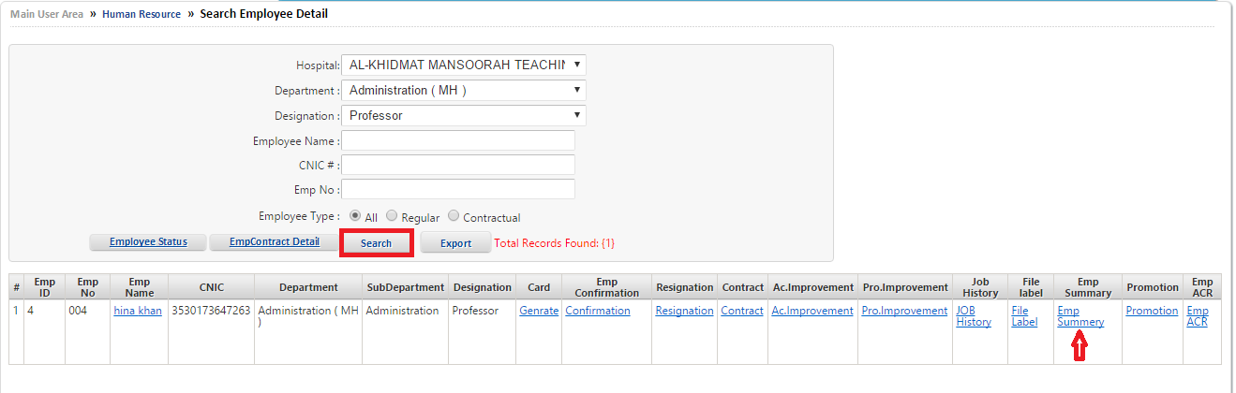

- After selecting employee Emp Summary.
- Employee Summary Report will appear on the screen.
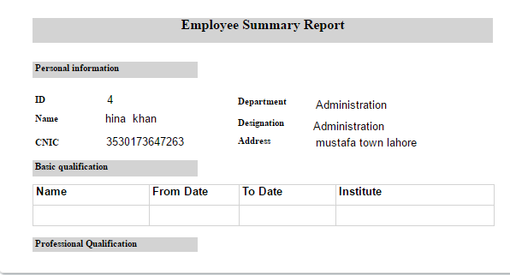

Employee Promotion/Demotion:
- Search Employee by different parameters by (Hospital, Department, Designation, Employee Name, CNIC #, Employee No).
- When Required Employee Information will be searched.
- Click on Promotion to see the Detail of employee promotion/demotion.

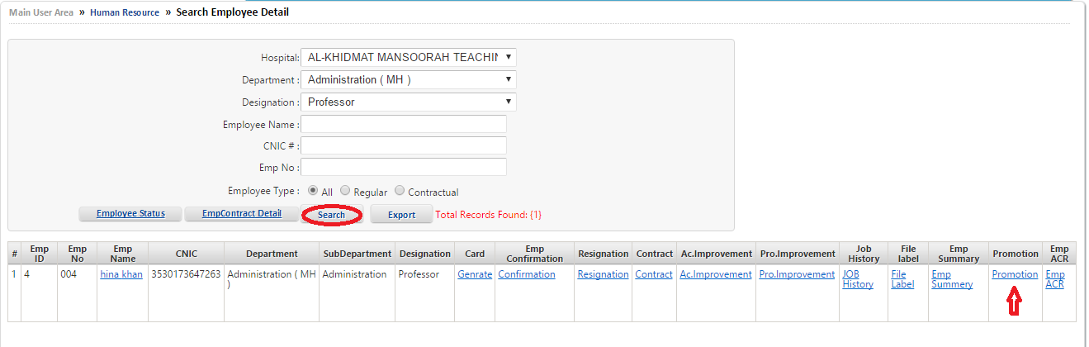
- After selecting employee Promotion.
- Employee Promotion Detail will appear on the screen.
- Select employee Current Designation.
- Select Promotion or Demotion radio button.
- Enter Promotion/Demotion Date.
- Select new Designation of employee from drop down list.
- Select name ordered by the person.
- Enter promotion/demotion description.
- Then click on save.
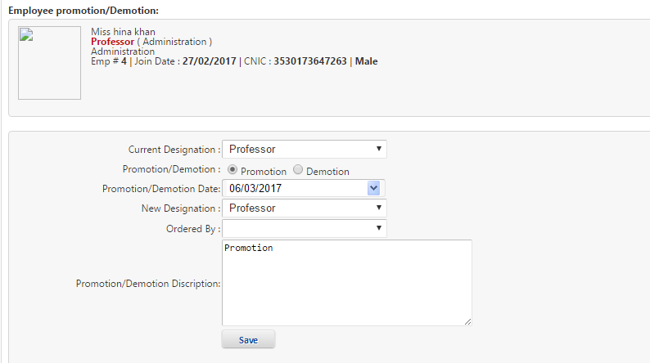

Employee ACR:
- Search Employee by different parameters by (Hospital, Department, Designation, Employee Name, CNIC #, Employee No).
- When Required Employee Information will be searched.
- Click on Emp ACR to see the Detail of employee ACR.

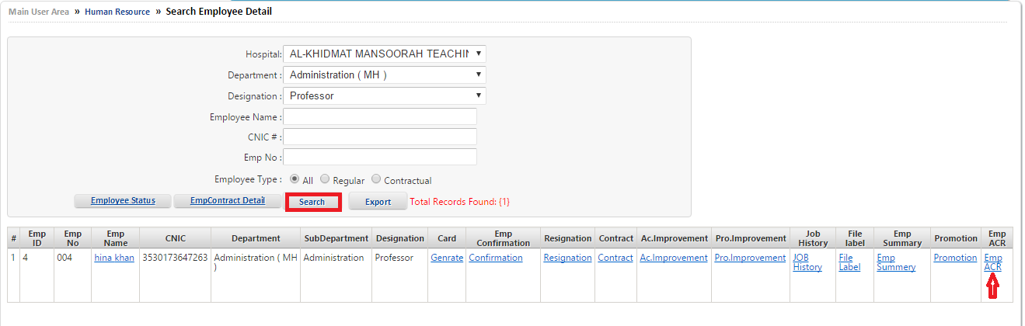

- After selecting employee ACR.
- Employee ACR Report will appear on the screen.

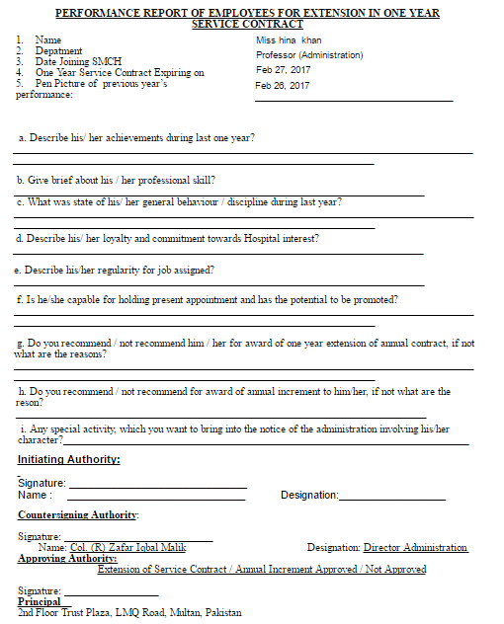

Employee Status:
- Click on HR module and select Search Employee from HR module list.
- Screen will appear as mention below:
- To see Employee Status click on Employee Status.

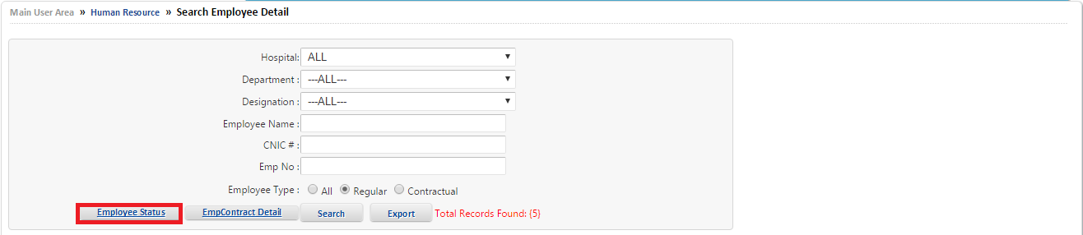

- After selection of Employee Status Employee Status Screen will beshow.
- Enter Start Date and Enter End Date in the text boxes respectively.
- To see the Current Employee detail between dates click on Current Employee.
- After selection of Current Employee list of Current Employee will be show at the bottom of the screen.
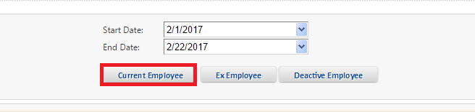
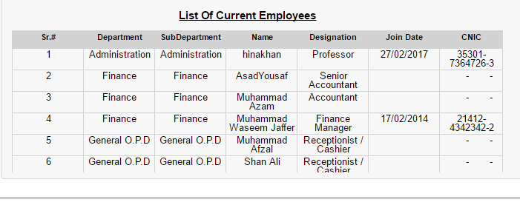

- To see the Ex Employee detail between dates click on Ex Employee.
- After selection of Ex Employee list of Ex Employee will be show at the bottom of the screen If any.
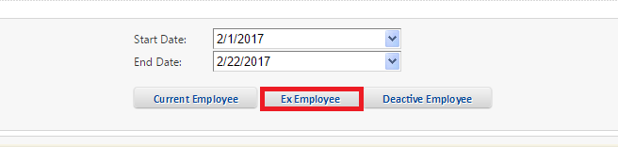

- To see the De-active Employee detail between dates click on De-active Employee.
- After selection of De-active Employee list of De-active Employee will be show at the bottom of the screen.

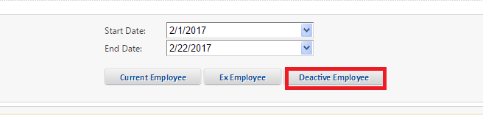

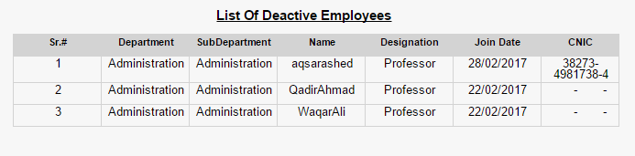

Employee Contract Detail:
- Click on HR module and select Search Employee from HR module list.
- Screen will appear as mention below:
- To see Employee Contract Detail click on EmpContractDetail.
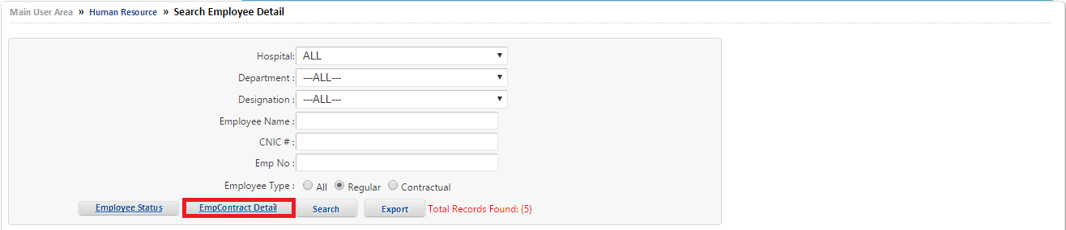

- After selection of EmpContractDetail list of Employee Contract Detail Screen will be show.
- See list of Expired Contracts or Pre Expiry by clicking on radio button.
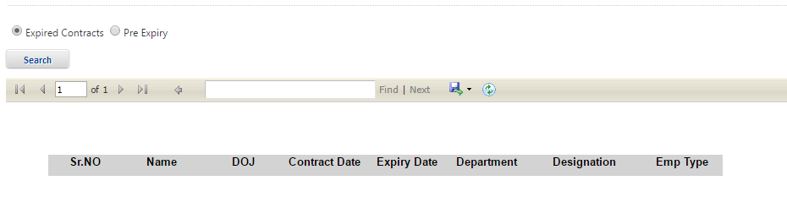

Export:
- Click on HR module and select Search Employee from HR module list.
- Screen will appear as mention below:
- To convert list of Employee Detail into Excel file click on Export.

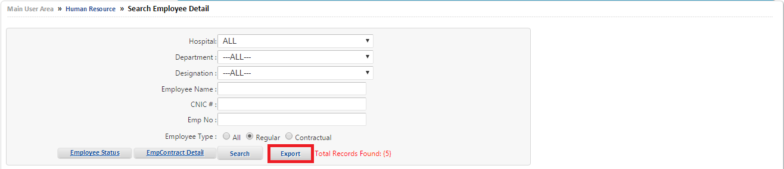

- After selection of Export the Detail of required filter employee will be show on Excel File.

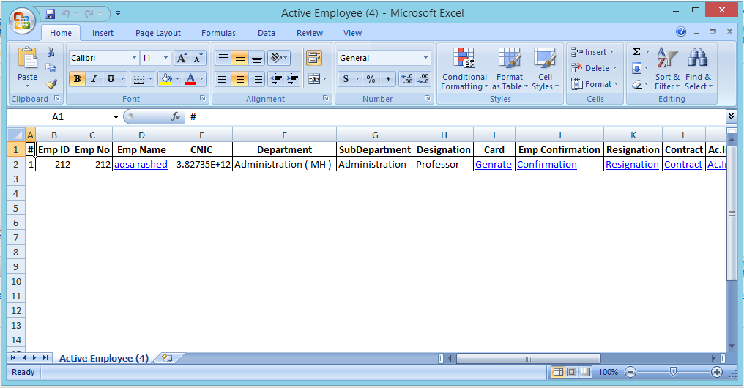

Additional information:
- Click on HR module and select Additional Information from drop down list of HR module.
- Screen will appear as mention below:

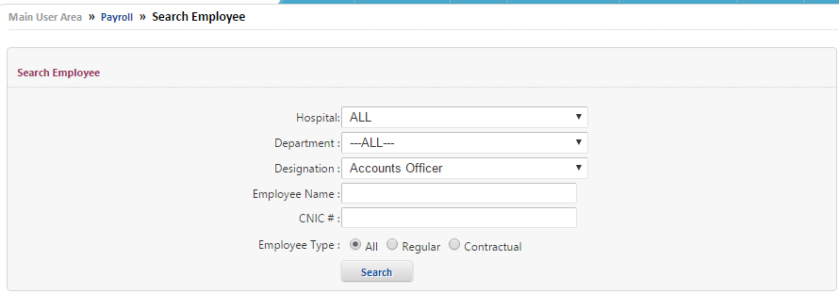
- Search Employee by different parameters by (Hospital, Department, Designation, Employee Name, CNIC #)
- When information is entered in the text boxes than select Employee Type by clicking on radio button.
- Then Click on Search.
- Required Employee Additional Information will be filter on screen.
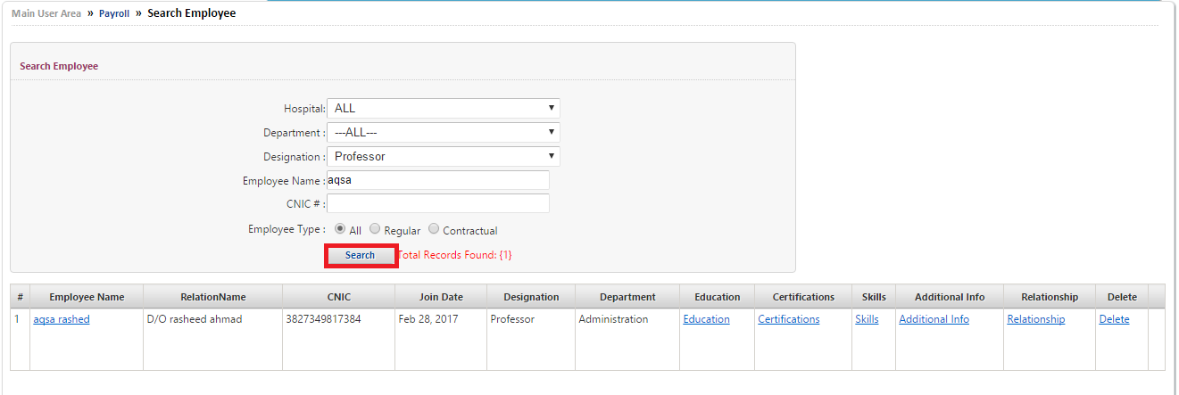

Edit Employee:
- Search Employee by different parameters by (Hospital, Department, Designation, Employee Name, CNIC #).
- When Required Employee Information will be searched.
- Click on Emp Name to Edit and Update additional information of employee.

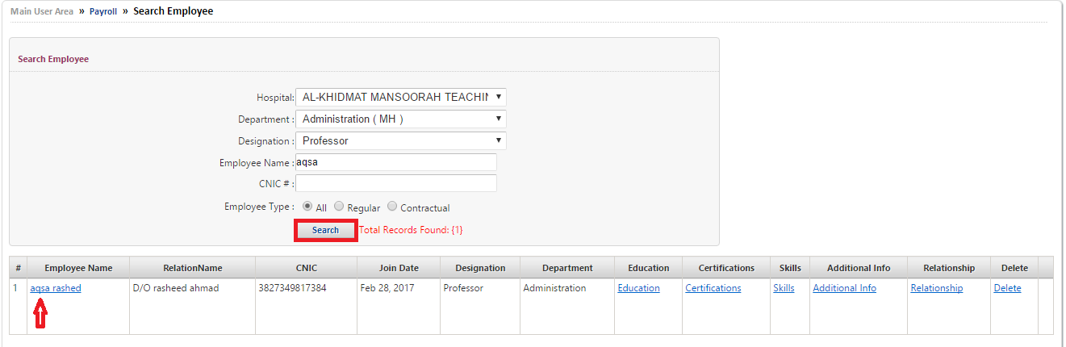

- After selecting Emp Name.
- Edit and Update General Information, Basic Information, Address Information, Employment Information
- Then Click on Update.
- Information will be edit or updated successfully.




Employee Education:

- Search Employee by different parameters by (Hospital, Department, Designation, Employee Name, CNIC #)
- When Required Employee Information will be searched.
- Click on Education to see and update employee education.

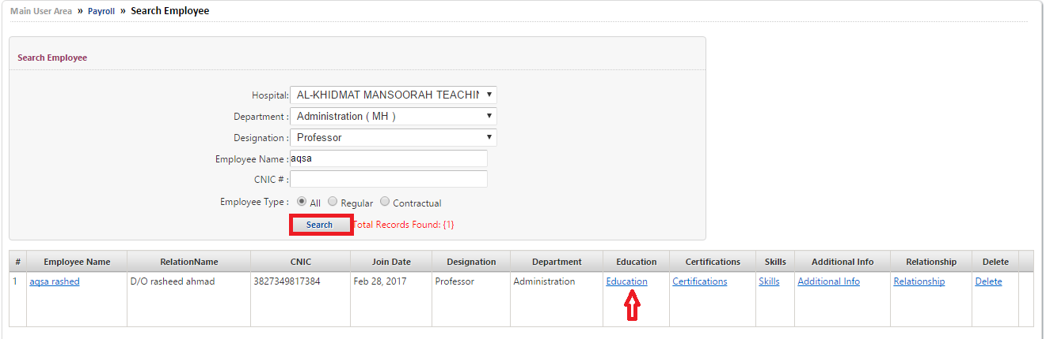

- Employee Education screen will appear.
- Enter employee Education detail in text boxes.
- Click on save.
- Information will save successfully.
- Saved information will appear below the screen.
(Note: On which text boxes mention the * sign that are compulsory)

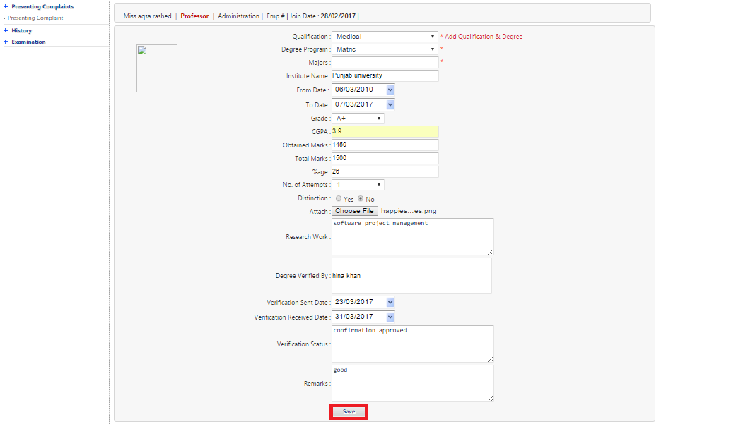

Employee Certification:
- Search Employee by different parameters by (Hospital, Department, Designation, Employee Name, CNIC #).
- When Required Employee Information will be searched.
- Click on Certifications to see and update certification information of employee.

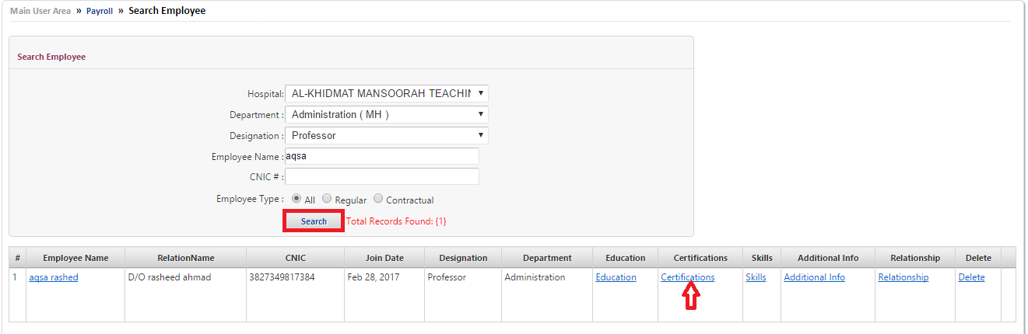
- Employee certification screen will appear.
- Enter employee Education detail in text boxes.
- Click on save.
- Employee certification information will save and will appear below the screen.
(Note: On which text boxes mention the * sign that are compulsory)
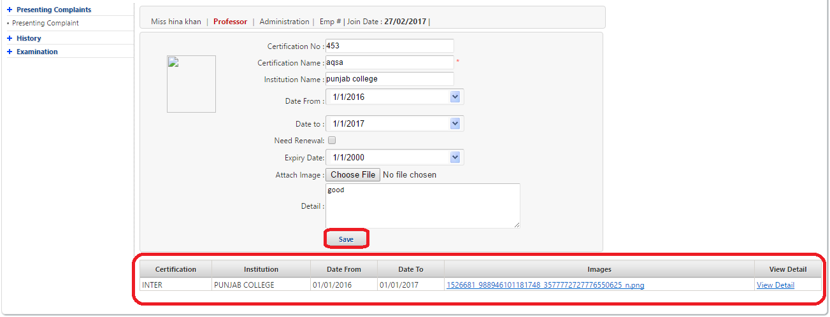

Employee Skills:
- Search Employee by different parameters by (Hospital, Department, Designation, Employee Name, CNIC #).
- When Required Employee Information will be searched.
- Click on Skills to Edit and Update skills of employee.

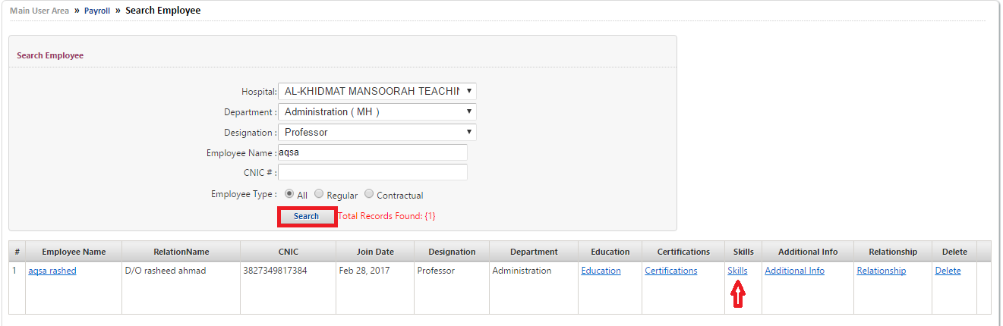
- Employee Skills screen will appear.
- Enter employee Skills detail in text boxes.
- Click on save.
- Employee skills information will save and will appear below the screen.

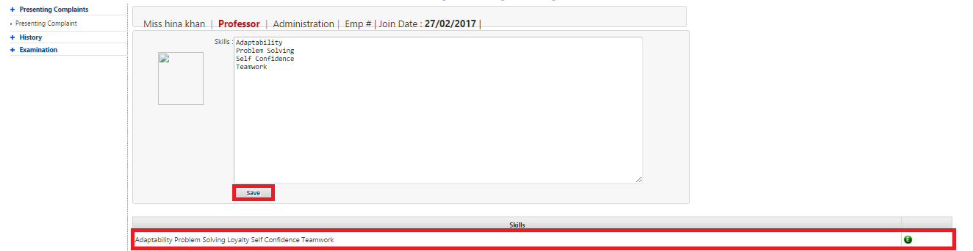

Employee Additional Info:
- Search Employee by different parameters by (Hospital, Department, Designation, Employee Name, CNIC #).
- When Required Employee Information will be searched.
- Click on Additional Info to Edit and Update further information of employee.
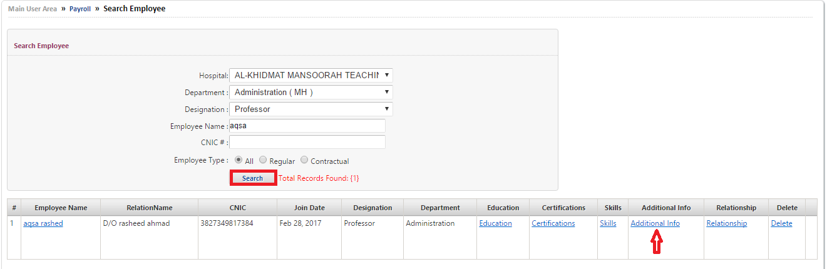
- Employee Additional Info screen will appear.
- Enter Objectives of employee in Objective text box.
- Select Language from drop down list.
- Enter employee Strengths of employee in Strengths text box.
- Enter employee Awards of employee in Awards text box.
- Enter employee Hobbies of employee in Hobbies text box.
- Click on save.
- Employee skills information will save and will appear the screen.
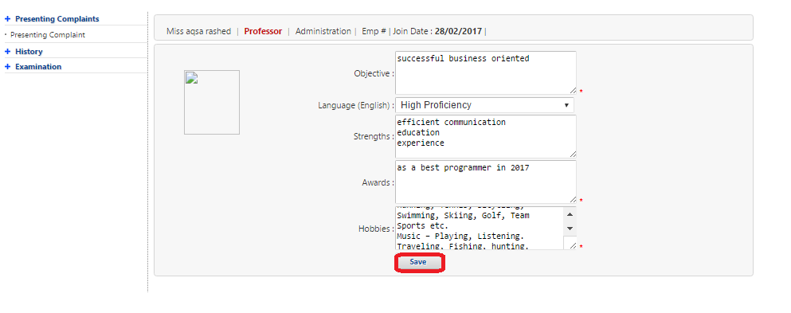
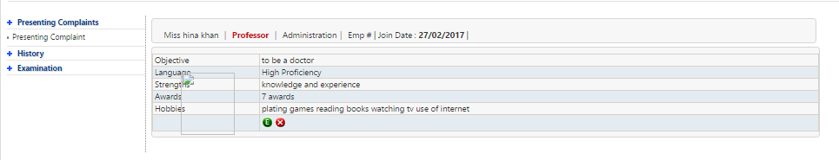

Employee Relationship:
- Search Employee by different parameters by (Hospital, Department, Designation, Employee Name, CNIC #)..
- When Required Employee Information will be searched.
- Click on Retionship to Edit and Update employee relationship information.
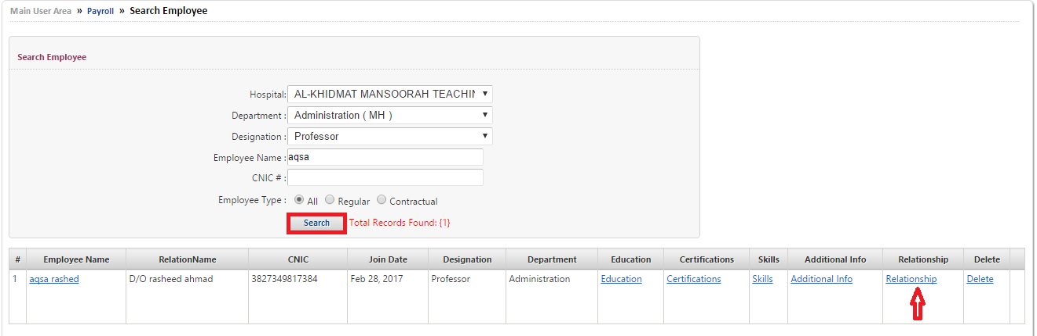
- Employee Relationship screen will appear.
- Enter employee information at the left side text boxes of screen.
- Enter employee Relationship information at the right side text boxes of screen.
- Select relationship with employee by clicking on radio Button.
- Click on save.
- Employee relationship information will save successfully and will appear below the screen.

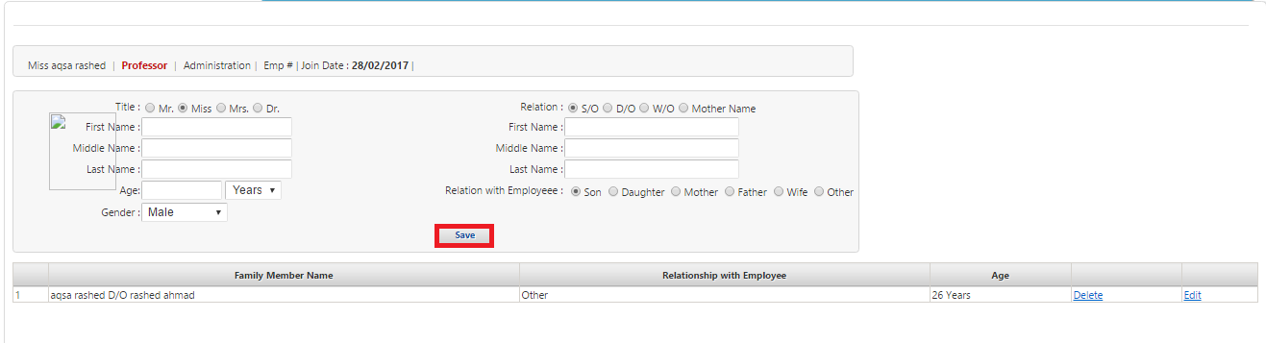

Delete Employee:
- Search Employee by different parameters by (Hospital, Department, Designation, Employee Name, CNIC #)..
- When Required Employee Information will be searched.
- Click on Delete to delete employee.
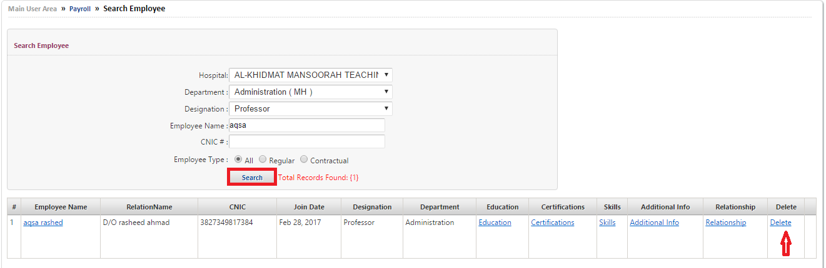

Active & Deactivate User:
- Click on HR module and select Active & Deactivate User from drop down list of HR module.
- Screen will appear as mention below:

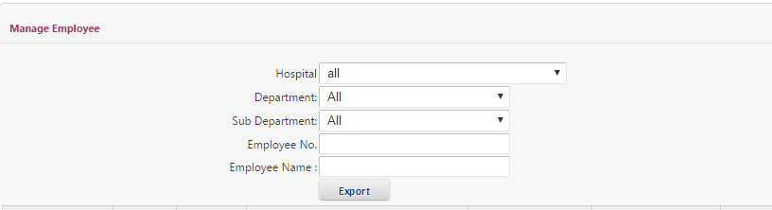

- Search User by different parameters by (Hospital, Department, Sub-Department, Employee No, Employee Name)
- When information is entered in the text boxes than click on Search.
- Required User Information will be filter on screen to active or Deactivate user.

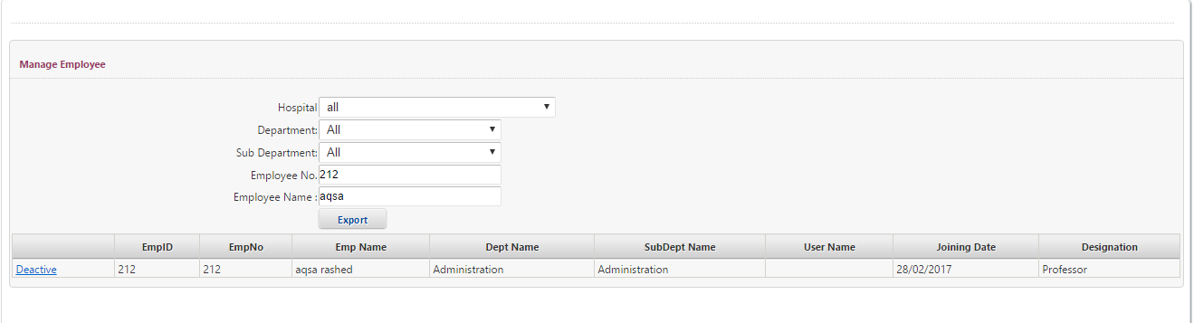

Active User:
- Search User by different parameters by (Hospital, Department, Sub-Department, Employee No, Employee Name)
- To active the user Click on Active which is at the left corner of the screen.

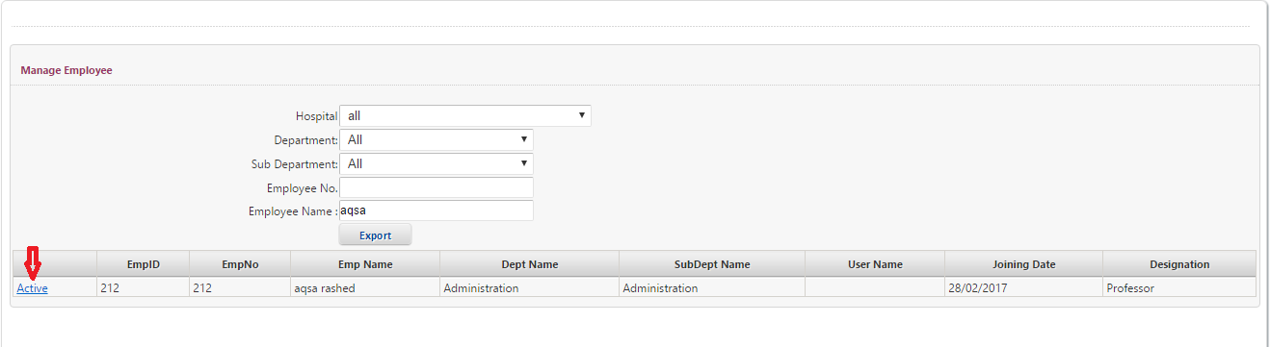

Deactivate User:
- Search User by different parameters by (Hospital, Department, Sub-Department, Employee No, Employee Name)
- To active the user Click on Deactivate which will show at the left corner of the screen when the user is active.
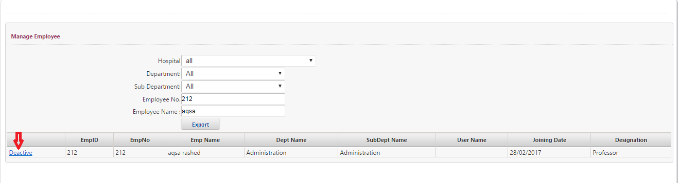

HR VS Employee / Divide Employee:
- Click on HR module and select HR VS Employee from drop down list of HR module.
- Screen will appear as mention below:
- Select Admin Employee from drop down list of Admin Employee select box.
- Select Department from drop down list of Department search box.
- Select Designation from drop down list of Designation search box.
- Enter EmpNO In EmpNo Search box.
- Then click on Search.
- Required Employee Information will be filter on screen.
- Select Employee by clicking on check box button.
- When Employee is selected click on insert.
- Information fill inserted successfully.

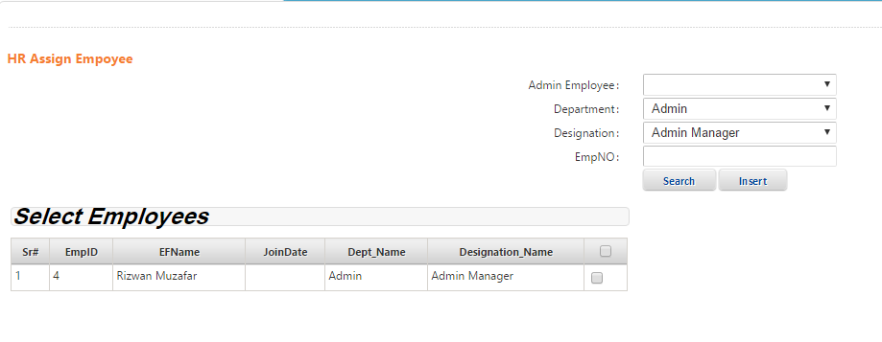

Staff Information:
- Click on HR module and select Staff Information from drop down list of HR module.
- Screen will appear as mention below:
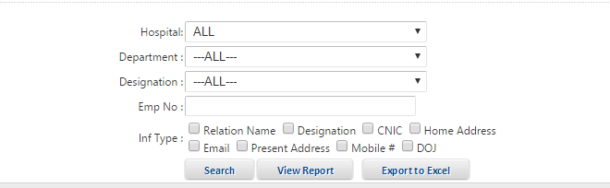

Search Employee:
- Search Employee by different parameters.
- Select Hospital from drop down list.
- Select Department from drop down list.
- Select Designation from drop down list.
- Select Staff Information Type by clicking on check box button.
- Click on Search.
- Required Staff Information will be filter on screen.
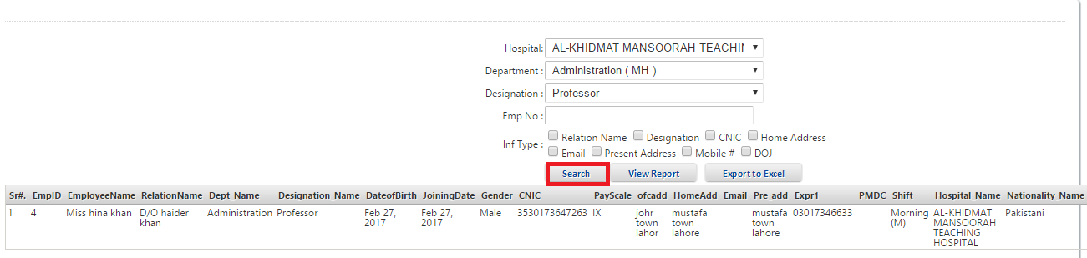

View Report :
- If to see Report of Required Staff Information.
- Click on Report
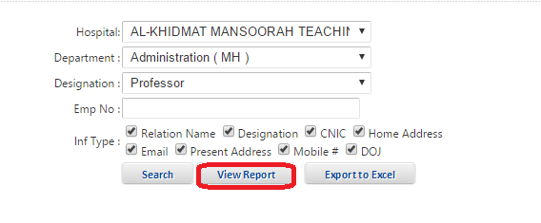
- Report of Required Staff Information will be filtered on the screen.
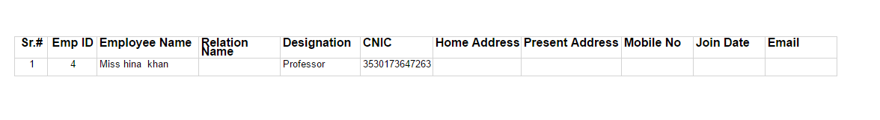

Export To Excel:
- Convert the Staff Information Report to Excel File.
- Click on Export.

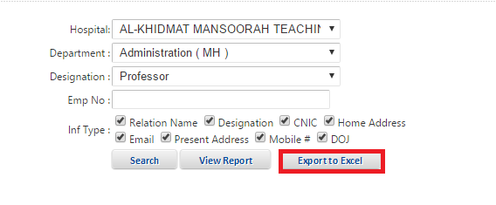
- Staff Information will be display on Excel file.



Update Payscale:
- Click on HR module and select Update Payscale from drop down list of HR module..
- Screen will appear as mention below.
- Select Designation from drop down list of Designation search box.
- Select Payscale from drop down list of Payscale select box.
- Click on Update.
- Information will updated successfully.

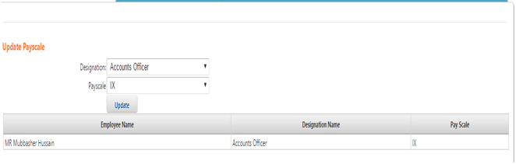

Status Tracking:
- Click on HR module and select Status Tracking from drop down list of HR module.
- Screen will appear as mention below:
- Select the name from drop down list of search text box.
- Active De-active employee status by authorize person will be show on the screen.

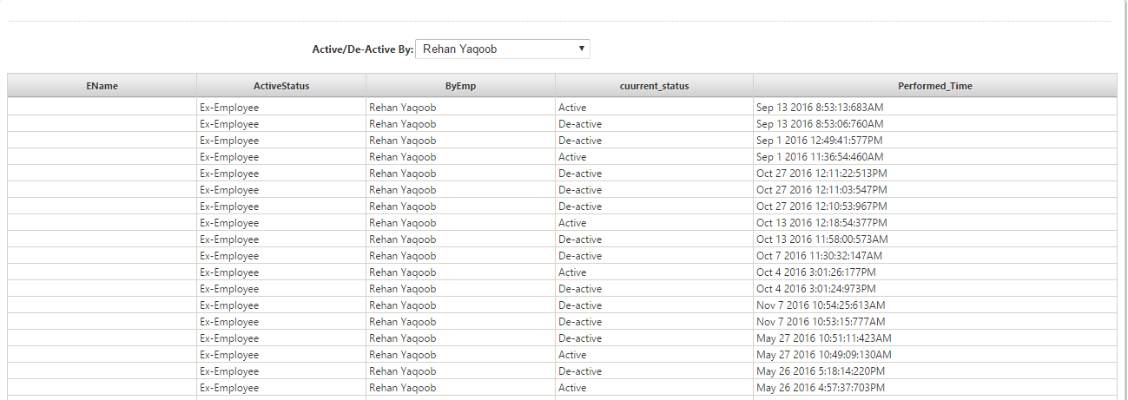

Add Department:
- Click on HR module and select Add Department from drop down list of HR module.
- Screen will appear for Add Department
- If department already exist click on search button then existing department details will appear at bottom of screen.
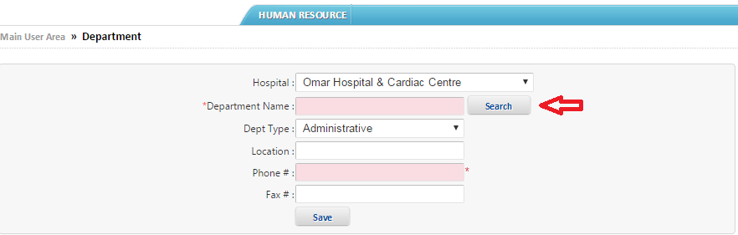
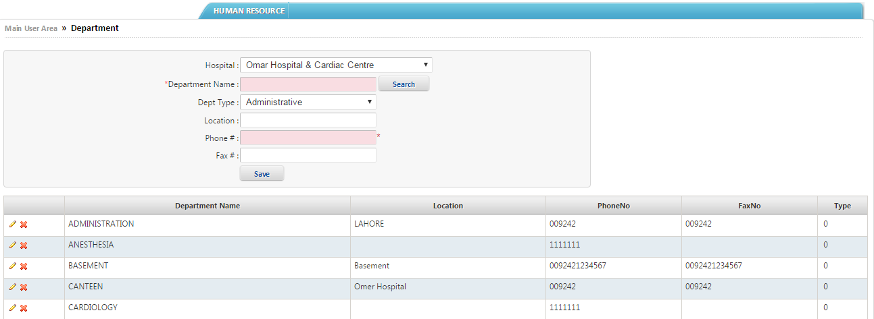
- To Add a new Department.
- Select Hospital name from drop down list.
- Write Department Name in text box.
- Select Department type from dropdown list.
- Add Location in text box.
- Add Phone Number in text boxes.
- Add Fax Number in text box.
- Click on save button.
- Further, for Delete or Edit existing sub department click on Delete image and Edit image as it show at the right corner of the screen.
(Note: On which text boxes mention the * sign that are compulsory)
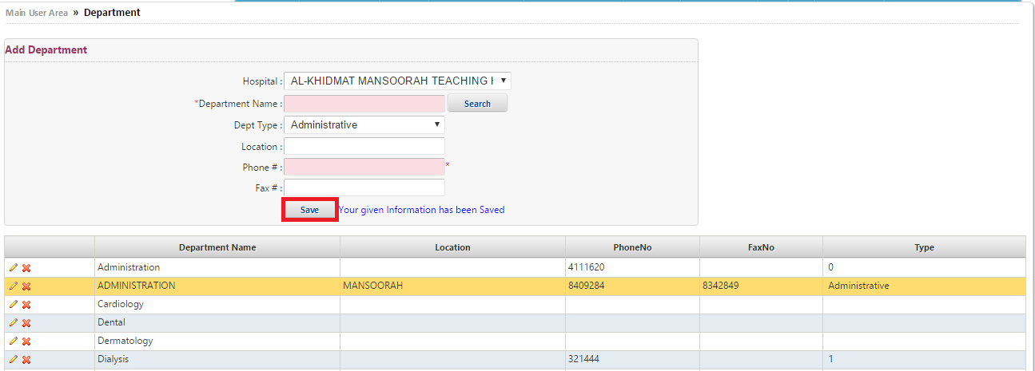

Add Hospital:
- Click on HR Module from menu bar.
- Select Add Hospital from drop down list of HR module.
- Enter Hospital Name, Abbreviation, Address, City, Phone, and Fax in text boxes respectively.
- Choose Logo Image from Choose File button.
- Click on save button.
- Hospital information will be save.
(Note: On which text boxes mention the * sign that are compulsory)

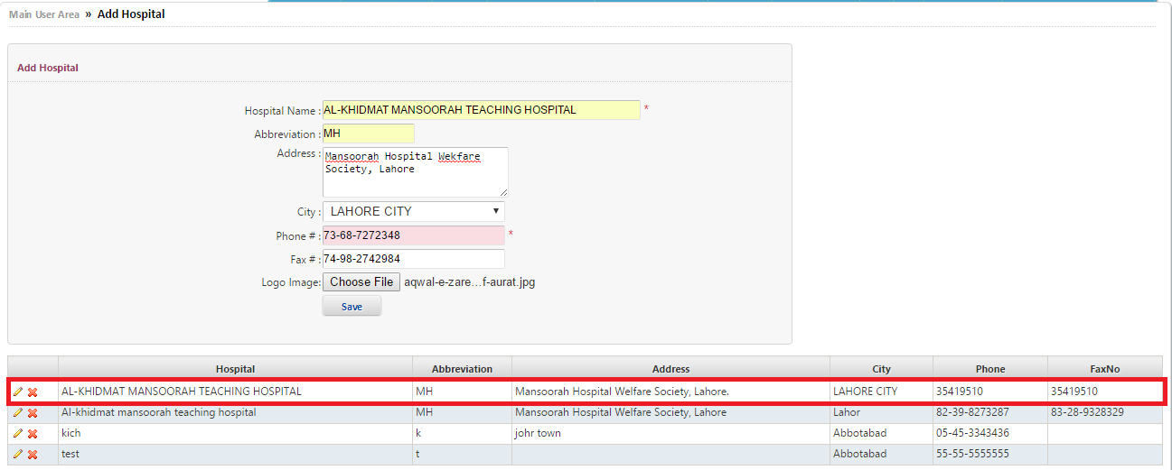

Add Sub-Department:
- Click on HR module and select Add Department from drop don list of HR module.
- Screen will appear for Add Department.
- Select Hospital name from drop down list.
- Select Department from drop down list.
- Add Sub Department name in text box.
- Select Department type from dropdown list.
- Add Location in text box.
- Add Phone Number in text boxes.
- Add Fax Number in text box.
- Click on save button.
- Further, for Delete or Edit existing sub department click on Delete image and Edit image as it show at the right corner of the screen.
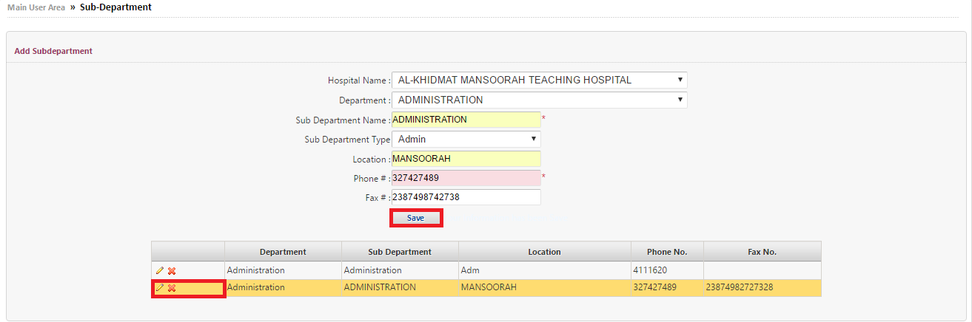

Resigned Employee Status:
- Click on HR Module from menu bar.
- Select Resigned Employee Status from drop down list of HR module.
- Select Hospital, Department, Sub Department from drop down list respectively.
- Enter Employee No, Employee Name in text boxes respectively.
- Click the Enter Button.
- Resigned Employee Status will appear at the bottom of screen.

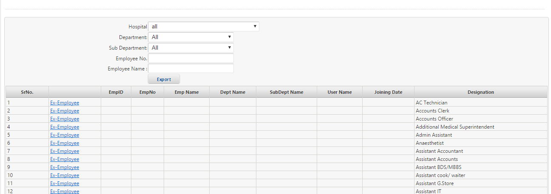

To convert the list of Resigned Employee Status to Excel file click on Export Button

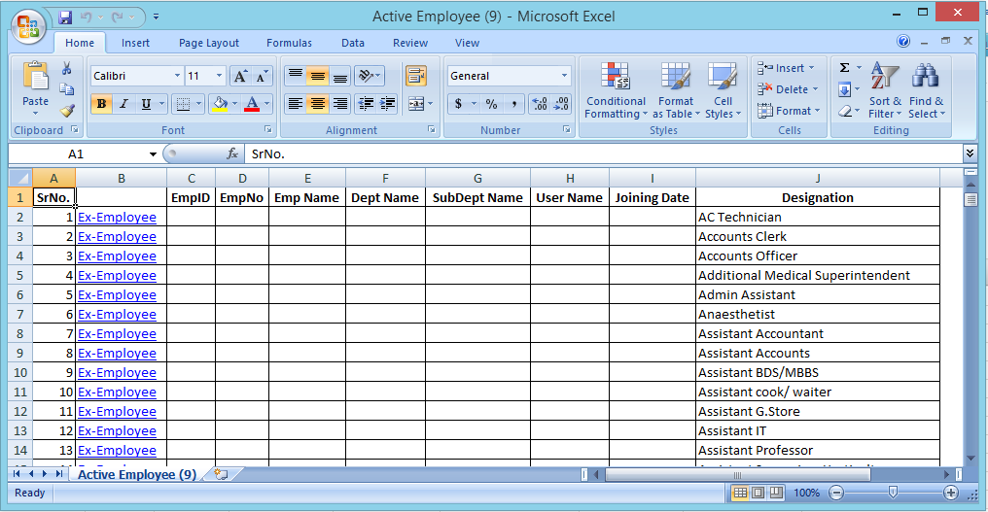

Add Designation:
- If add new Designation of any employee.
- Click on HR module and select Add Designation from drop down list of HR module.
- Screen will appear for Add Designation.

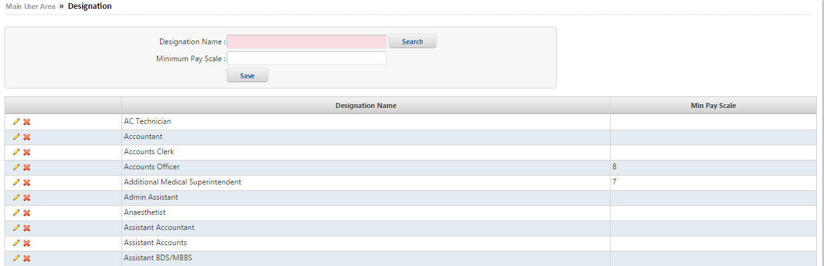
- Write Designation Name in text box.
- Write Minimum Pay Scale in text box.
- Click on Search button.
- Click on Save button.
- Designation will be added.

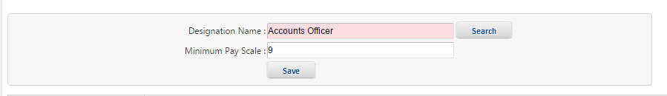
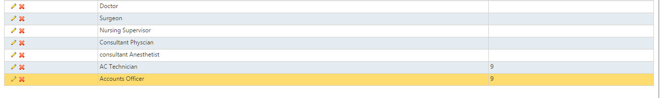

Mark Receptionist:
- Click on HR module and select Mark Receptionist from drop down list or HR module.
- Screen will appear to mark receptionist.
- Enter ID in Enter ID text box.
- Click on Mark Receptionist
- Information will be insert successfully.


Mark Visiting:
- Click on HR module and select Mark Visiting from drop down list or HR module.
- Screen will appear to mark visiting.
- Enter ID in Enter ID text box.
- Click on Mark Visiting.
- Information will insert successfully.
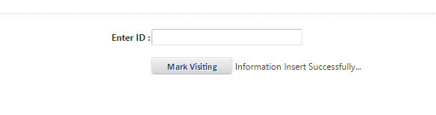

Manage User Role:
- Click on HR module and select Manage User Role from drop down list of HR module.
- Screen will appear to assign user role.
- Enter Role Name in Role Name text box.
- Select Department from drop down list of Department.
- Click on Save.
- Information will be saved successfully.

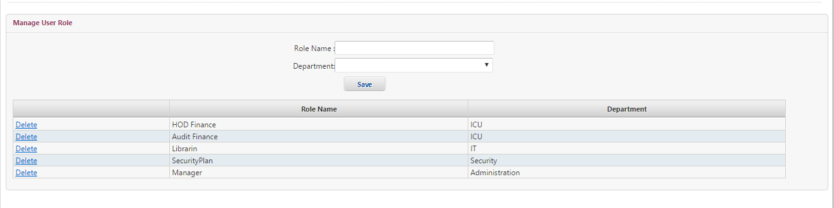
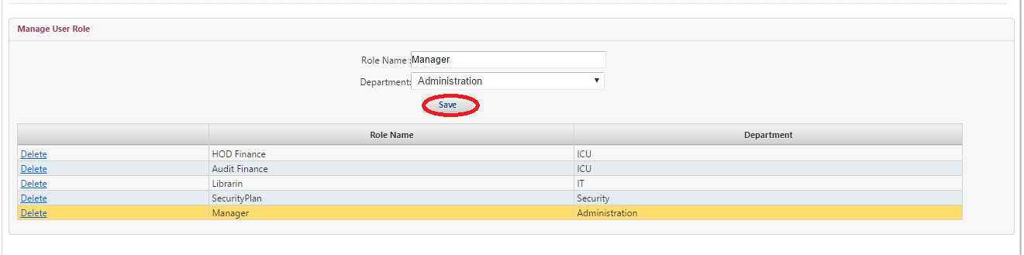

Employee Roles:
- Click on HR module and select Employee Role from drop down list of HR module.
- Screen will appear to assign user role.
- Select Role from drop down list.
- Select Module Name from drop down list.
- Click on check box to select pages.
- If selected all pages then click on CheckAll button.
- If not selected all pages then click on UnCheckAll button.
- Click on Save.
- Pages will be inserted successfully.
- If to delete the page from selected list Click on delete.

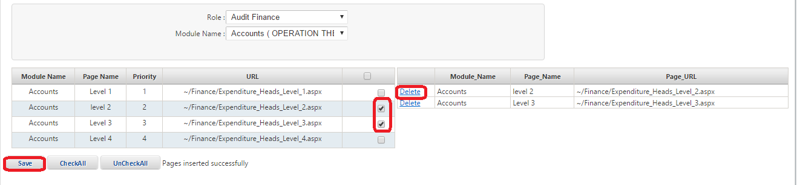

Employee Roles By Department:
- Click on HR module and select Employee Roles By Department from drop down list.
- Screen will appear to see the list of Employee roles.
- Select Department Name from drop down list.
- Select Sub Department Name from drop down list.
- Select Employee Name or Login Name.
- Select Role from drop down list.
- See the list of Employee roles assign by department.
- If to delete Employee pages then click on delete.
- If to delete Role then click on delete
- Click on Save.
- Information will be updated successfully.
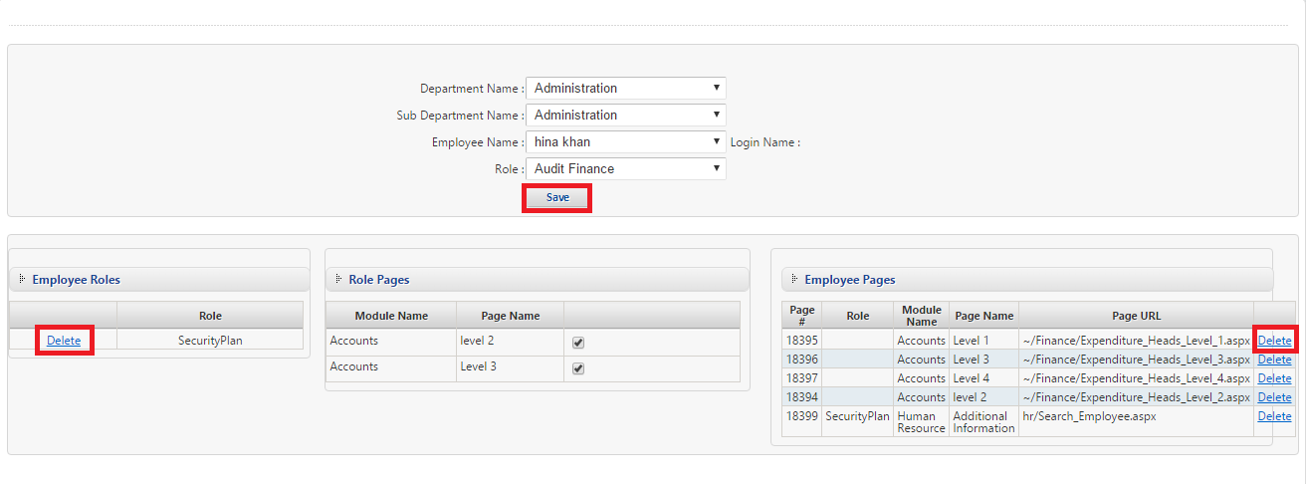

Assign Pages To Role:
- Click on HR module and select Assign Pages To Role from drop down list or HR module.
- Screen will appear to assign pages to role.
- Select Module from drop down list.
- Enter Page Name in text box.
- Enter Page Url in Page Url text box.
- Click on Add Page.
- Page will added successfully.
- If to Edit or Delete the page from selected list Click on Edit / Delete.

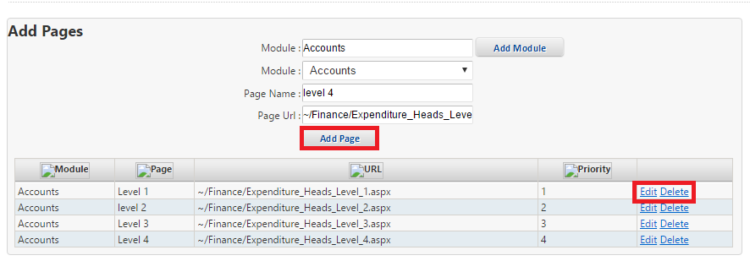
- After Add Page then Assign this Page.
- Select Department from drop down list.
- Select User Name from drop down list.
- Select Module ID from drop down list.
- If selected all pages then click on CheckAll button.
- If not selected all pages then click on UnCheckAll button.
- If selected some pages then click on Assign Pages Check Box button.
- Click on Save.
- Pages will be assigned successfully.

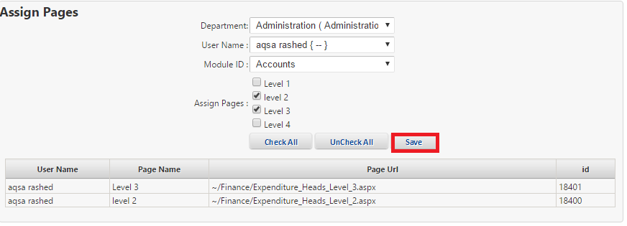

Update Employee Code:
- Click on HR module and select Update Employee Code from drop down list or HR module.
- Screen will appear as mention below.
- Select Hospital name from drop down list.
- Select Department from drop down list
- Select Designation from dropdown list
- Enter Employee Name in Employee Name text box.
- Enter CNIC in CNIC text box.
- Enter Employee No in Employee no text box.
- Select Employee Type by clicking radio button.
- Click on Search.
- Employee information will be filtered on the screen.
- To change department click on Change Department.
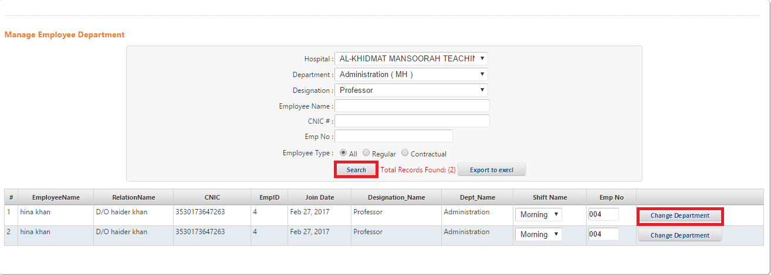

Change department:
- After click on change department Screen will be appear as mention below.
- Select Department from drop down list.
- Sub Department automatically will be changed.
- Then click on Save.

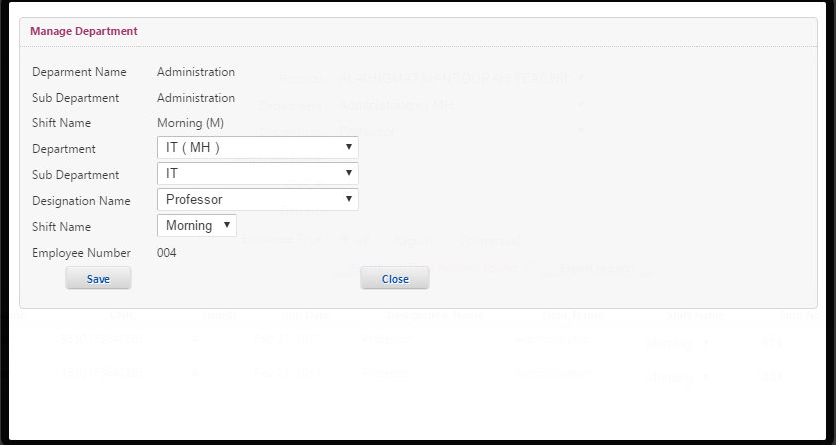

- To convert the employee department information into Excel File click on Export.
- Information will be printed in excel file as mention below the screen.
